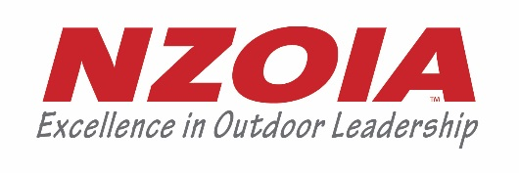
Nomination Form – Elected Board Member Positions 2021
Nominations are open for one elected NZOIA Board position. Check out the AGM and Board of Director Election information for nomination forms and more info. Nominations are now open and are due by Friday 17 September 2021. Late nominations will be taken up to the date of the AGM, however they will only be announced at the AGM. Nominations received before 17 September will be emailed out to the Membership with the agenda so those who cannot attend have the opportunity to cast a proxy vote. Voting and announcement will take place at the NZOIA AGM on Sunday 17 October 2021 or online via Zoom if the AGM is postponed due to Covid-19 Alert Levels.

Nominations can be emailed:

Email: board@nzoia.org.nz

Nominees for the Board Member positions must:

- be a current financial member of NZOIA;
- be 18 years of age or older as at the date of the nomination;

Please complete all parts of this form and ensure it is signed.

PART A: NOMINATOR DETAILS
Name of Nominator: |  | Membership Number:

PART B: NOMINEE DETAILS
Name of Nominee: |  | Membership Number:
I confirm that I am eligible to be nominated for a Board Member position in accordance with the NZOIA Constitution and Regulations. I also consent to this nomination.

Signature of Nominee: _________________________________ Date: ________________

Please complete the following pages regarding your experience and what you can bring to the Board.

PART B Continued… (nominee to complete)
Please fill in the following (attach separate pages if necessary) OR attach a Curriculum Vitae
Qualifications
Experience as a director, trustee and/or other governance role
Knowledge and experience of the outdoor sector
Personal strengths and abilities / key skills
Reasons for nomination
General – any other comments you wish to have considered

PART C: PRIVACY ACT 1993 (Nominee to complete)

I agree that NZOIA may collect and retain the information supplied with this nominations and NZOIA may authorise the release of this information to NZOIA Members and any other persons or organisations that NZOIA considers appropriate.

Signature of Nominee: _________________________________ Date: ________________

