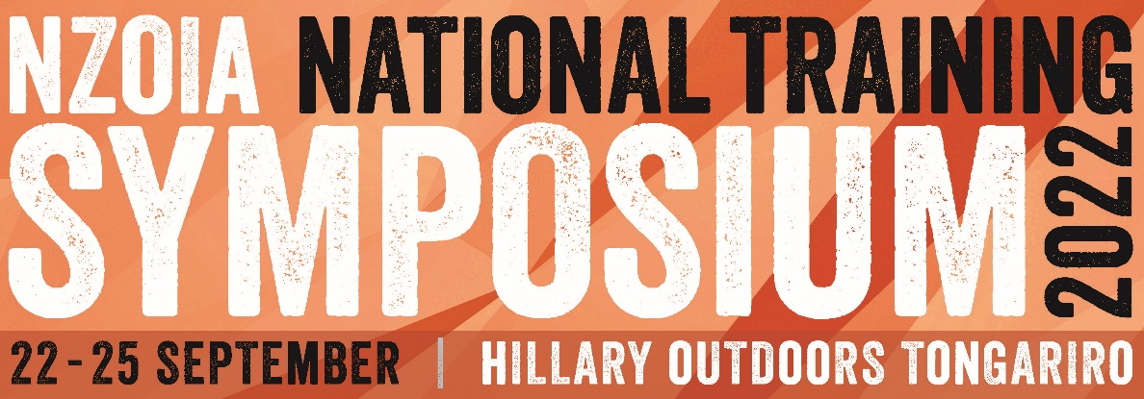

Professional Development Workshop Facilitation
Thank you for your interest in facilitating a Professional Development Workshop at the NZOIA Training Symposium. This is a great opportunity to give back to your industry and share something that you are passionate about. The Symposium is aimed at our ‘on-the-ground’ instructors, workshops should have a practical element, or be aimed at how to incorporate the theory in practice. Please fill in the below form and email back to – symposium@nzoia.org.nz
Workshop Title | What is your workshop going to be called? Make is something catchy to attract participants
Who is running the workshop? | Who is going to run the workshop? Are they representing an organisation?  Are you/the person running the workshop planning on attending the full Symposium?
Contact details | Phone and email:
Facilitators Qualifications/Experience | What qualifications/experience do you and any other facilitators have to run this workshop?
What? | What is the workshop about? What will people learn? Make this sound interesting as this is what we will use to advertise your workshop!!
What experience do participants need to attend your workshop? | Where possible we try and keep professional development workshops open to anyone, but if your workshop requires specific experience/quals i.e. Able to kayak grade 3, please list it here.
When?  Preferred day & timeslot... | Friday 23 September 2022 ☐ Full day ☐ AM ☐ PM
 | Saturday 24 September 2022 ☐ Full day ☐ AM ☐ PM
How long?  Workshops are generally a ½ day (3-4 hours) or full day (8/9am to 5pm). | How long?: Approx. times (ie. 800 – 1200):  NB: ½ day workshops are popular with participants and facilitators as it allows more flexibility for attending other workshops. Feel free to run the same workshop in different timeslots if you wish.
Equipment  Do people need to bring anything specific for this workshop or will you provide materials? | List any equipment participants need to bring  List any equipment you would like NZOIA to organise on your behalf (ie. sea kayaks, projector)
Numbers | Is there a maximum number of people you can take? Note: For some activities you may be restricted by ratios outlined in the NZOIA SMP. If there are qualified participants on the course, we may increase the ratios. Please contact NZOIA if you have any questions.
Location | What is the ideal location for your workshop? E.g. Some classroom/some outdoor area. Ocean/River/Pool/Bush/Rock etc. Do you require a room?
Vehicle | Do you require a vehicle for your workshop? Are you able to provide this, or would you like us to organise one for you?  Do you have a P endorsement or class 2 licence? May be needed for our hire vehicles.
Anything else?
What else do you need to make this workshop a success?
What can NZOIA do to help?
When finished, please save and email to – symposium@nzoia.org.nz

